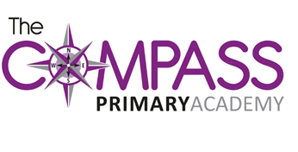
The Compass Primary Academy
Windmill Avenue
Kettering
Northants
NN15 7EA
t: 01536 532707
w: www.compassprimary.org
e: office@compassprimary.org

29th June 2017

Dear Parents of Year 6

You are invited to the year 6 end of year performance of:

‘Aladdin’
Wednesday 19th July 2017
6.30pm
(doors open at 6.15pm)

We hope that you can all come and support your son/daughter in their last performance at Compass Primary Academy. They have all worked very hard rehearsing and learning their lines. All year 6 children must be at school by 5.30pm so they can get into costume and character.

We have allocated 2 places per child. Please complete the return slip below or reply via the parentmail app.

As the children and staff have been working hard to prepare for the performance, we ask that babies and pre-school children are NOT brought to the performance. There will be a crèche available for children under 5. Please indicate how many places in the crèche are required and the ages of the children. If you have older children they will need to have an allocated seat and cannot sit on parents laps.

Yours sincerely

Mrs Wright and Mr Jennings

‘Aladdin’ – Wednesday 19th July 2017

Childs Name: _______________________________________ Class ___________

Number of places required: ___________________________

Name of people attending: _________________________________________________

_________________________________________________

Names of Children attending the Crèche _____________________ Age ____________

_____________________ Age ____________

