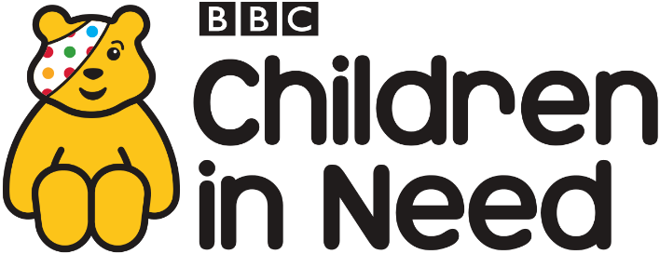
Children in Need

This year we will be raising money for Children in Need by having a ‘Spotty bake sale’. The School Council children will be selling cakes every break time for 50p each.

Please can you donate cakes for the children to be able to sell next week?
If your child would like to buy a cake please send them with 50p.
The School Council children will be selling cakes week commencing 13th November until 17th November.
On Friday 17th November please send your child to school wearing something spotty. Please send £1 contribution, all old pound coins will be accepted to help the charity.

Thank you for your support.

Miss Bradbury

