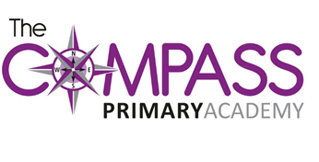
The Compass Primary Academy
Windmill Avenue
Kettering
Northants
NN15 7EA
t: 01536 532707
w: www.compassprimary.org
e: office@compassprimary.org

Dear Parents
Reception school reports

This year your child’s school report will uploaded onto Tapestry on Monday 17th July 2017.

We are aware that some parents have not accessed their tapestry account for some time. Please speak to a member of staff who can reset your password or change email addresses if needed.

Yours sincerely

Miss Bradbury
EYFS Lead

