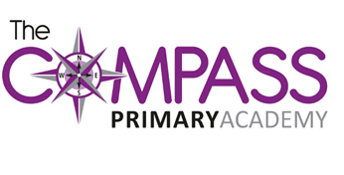
The Compass Primary Academy
Windmill Avenue
Kettering
Northants
NN15 7EA
t: 01536 532707
w: www.compassprimary.org
e: enquiries@compassprimary.org

8th June 2017
Dear Parents/Carers
Re: Residential Trip PGL, Claythorpe
Wednesday May 2nd – Friday May 4th 2018

We are pleased to inform you that enough interest has been shown for the trip to go ahead. The school will be subsidising the trip so we can now confirm the cost will be £195 per pupil.
The following payments are due as below but please feel free to come in and make any payments at any time, weekly or monthly, if this helps to spread the cost.
1st payment of £35 due by Friday 7th July 2017
2nd payment of £35 due by Friday 15th September 2017
3rd payment of £35 due by Friday 24th November 2017
4th payment of £35 due by Friday 26th January 2018
5th payment of £20 due by Friday 20th March 2018
A reminder will be sent out when the next payment is due and further details regarding kit list, activities, times and dates will be sent nearer to the trip.
No outstanding balance on pupil account
The Principal reserves the right to refuse a place to any pupil who has a substantial outstanding balance on their lunch, breakfast club or extra curriculum clubs account.
Also, either on payment of the deposit or at any time thereafter. In addition, it is expected that all accounts will be settled in full no later than one month prior to departure.

Please read the Terms and Conditions overleaf and if you have any queries do not hesitate to contact the school office.
Yours sincerely
J Fallowell
Mrs J Fallowell
Principal

